1. **Character Tracing:**

**Step 1:** Open a new animate cc file with 1960X1080 resolution .

**Step 2:**Open the reference image in the animate cc.

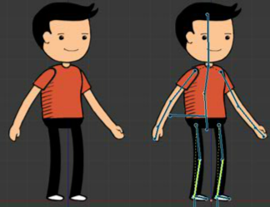

**Step 3:** Now using various layers and symbols and colours draw the character just like tracing an image on paper.

**Step 4:** Now combine each symbol as their respective part like head , hands etc.

**Step 5:** Now use bone tool for the whole body and the character is ready.

